**ENSF-381**: **Full Stack Web Development Laboratory**

**Lab03**

**Section: L01**

**Group information:**

Azlan Qamar: 30241636

Mazin Mazin: 30243457

**GitHub Link: <https://github.com/407-Proxy/ENSF381>**

**Exercise 1 Output Screenshot:**

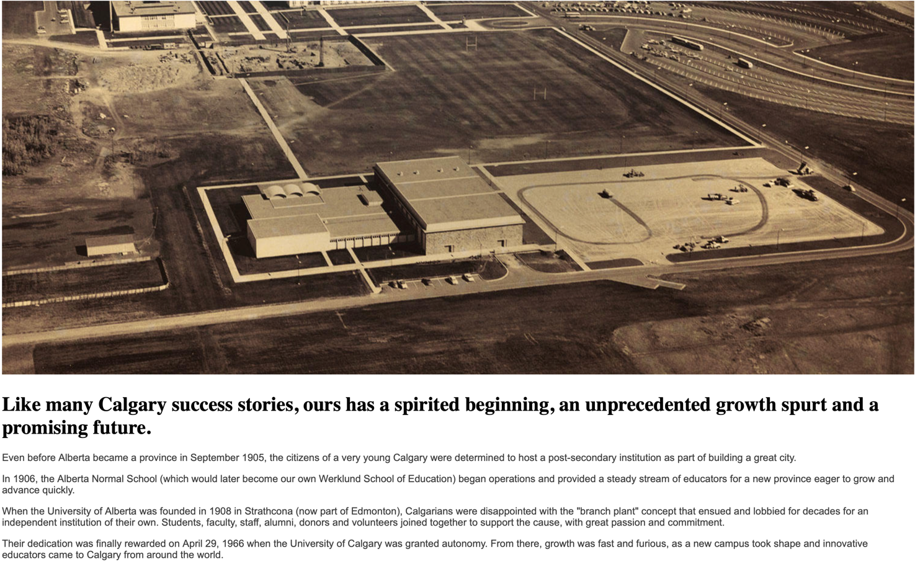

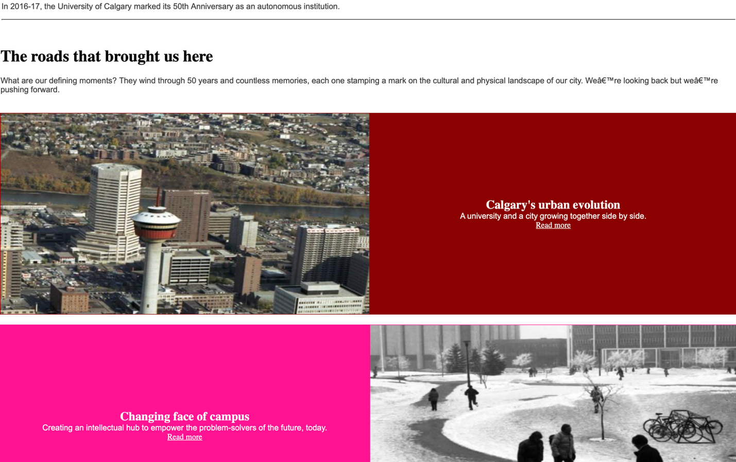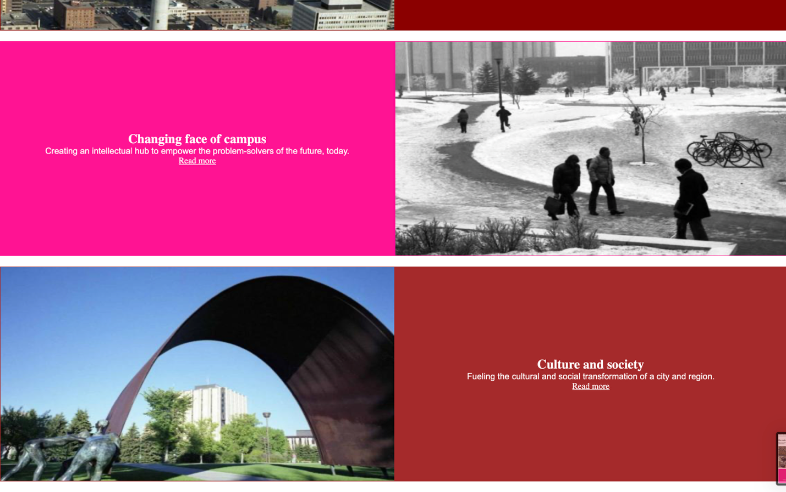

**Exercise 2 Output:**

Screenshot from step 6:

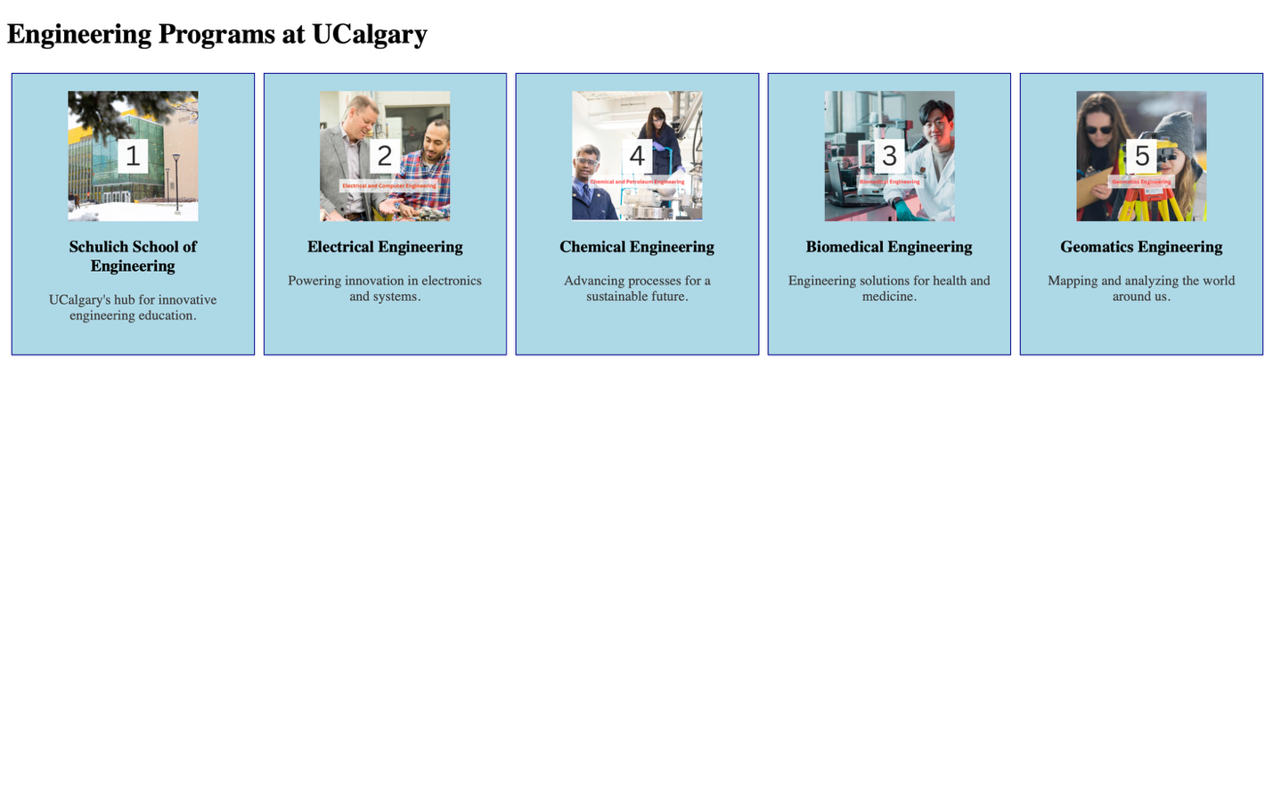

**S**creenshot from step 8:  
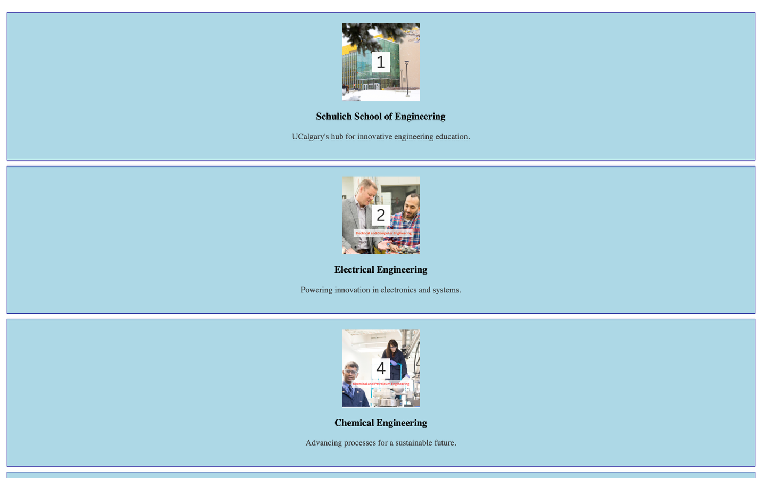  
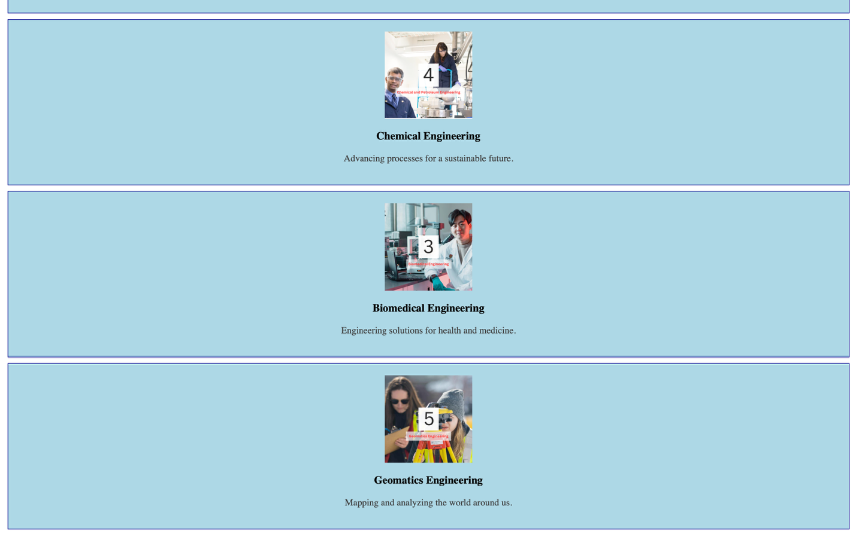

**Two** Screenshots from step 9: 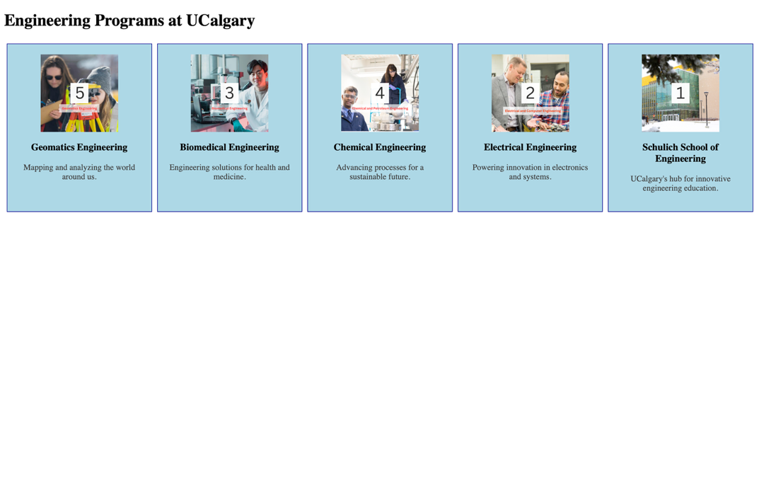

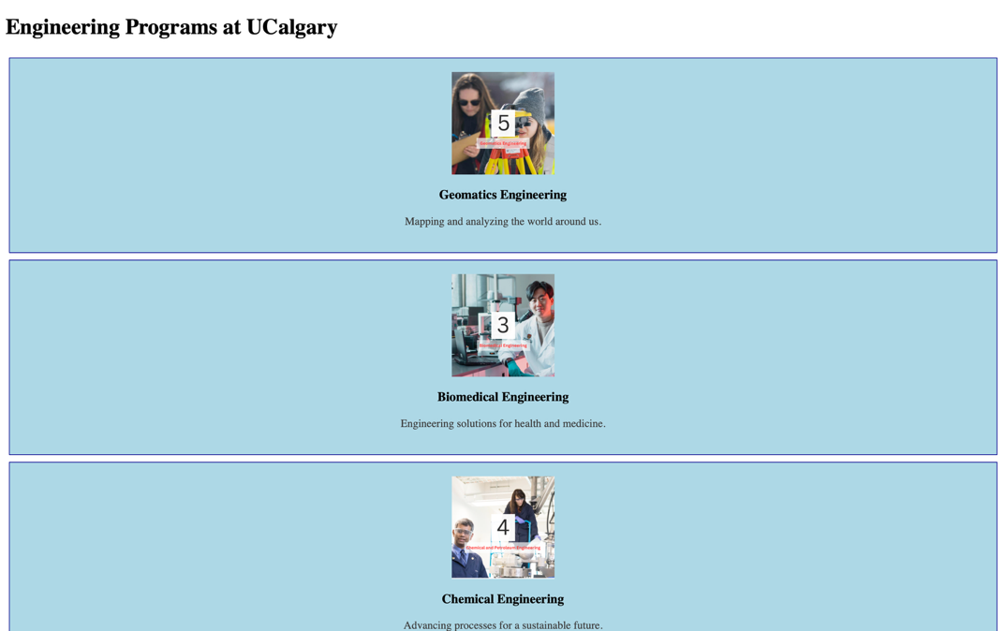

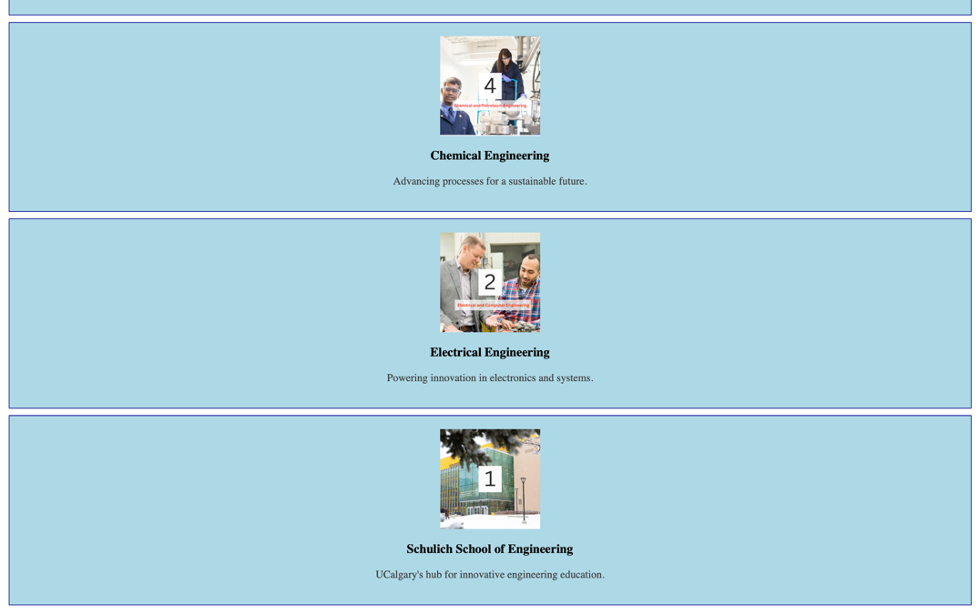

Screenshot from step 12:



Screenshot from step 14:

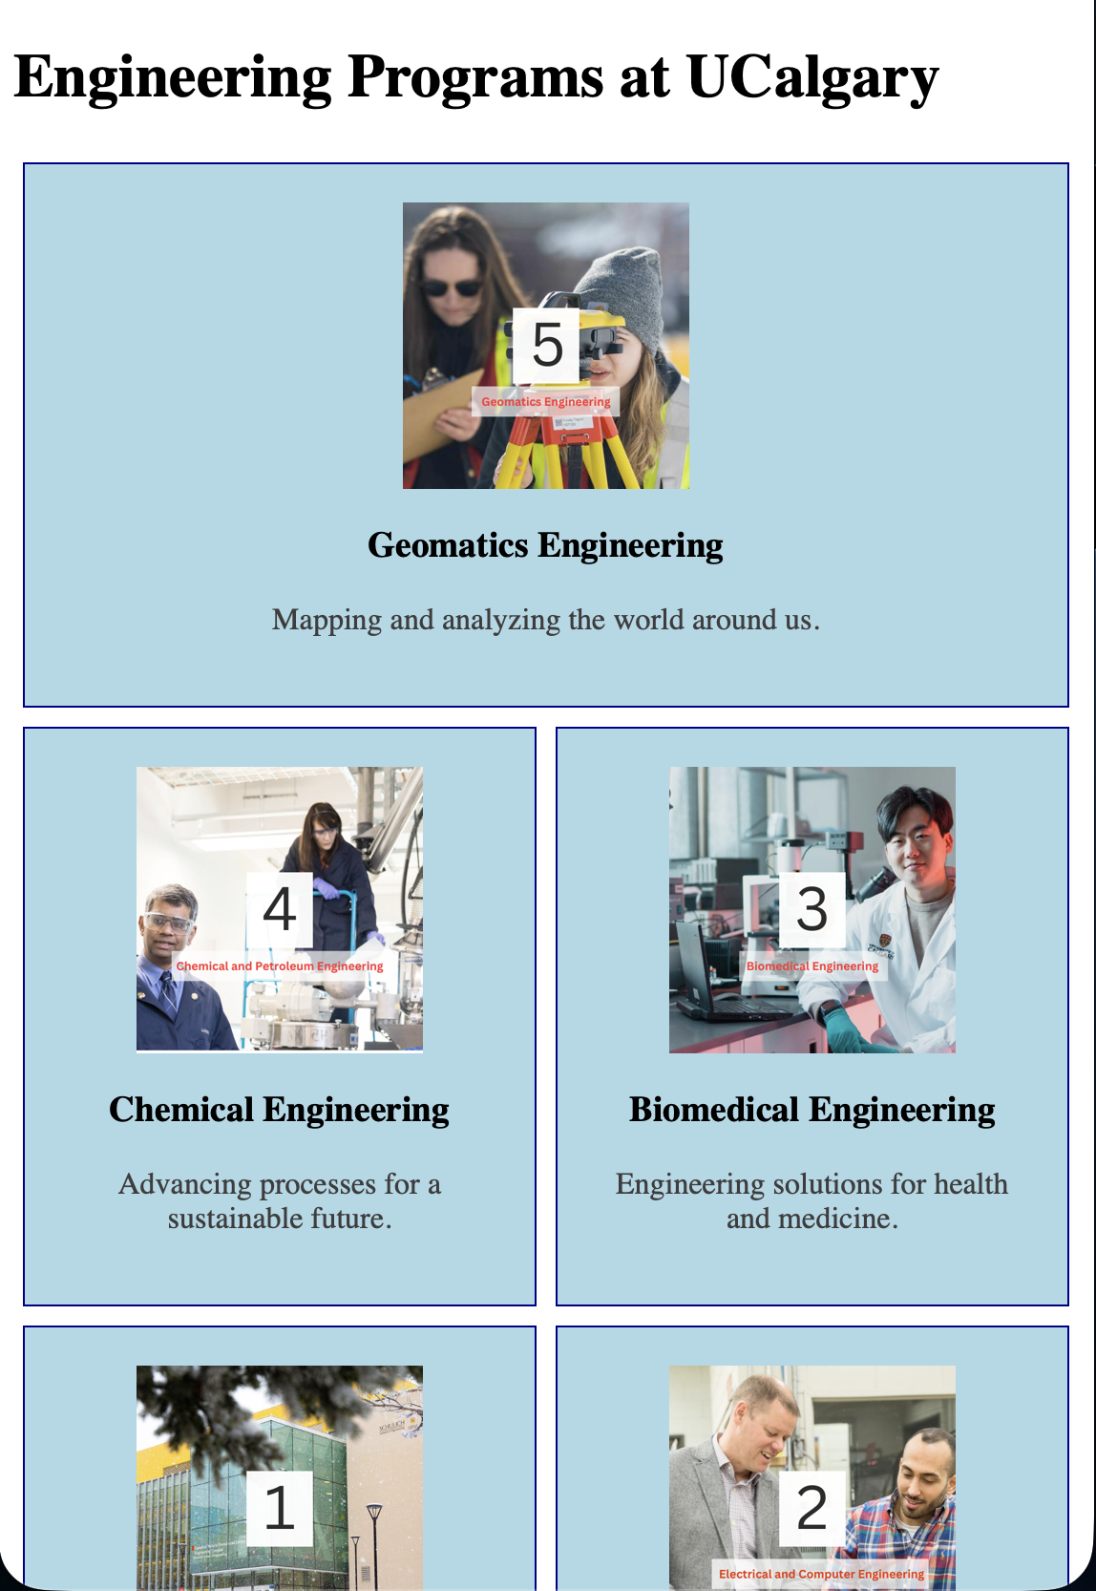

Screenshot from step 16:

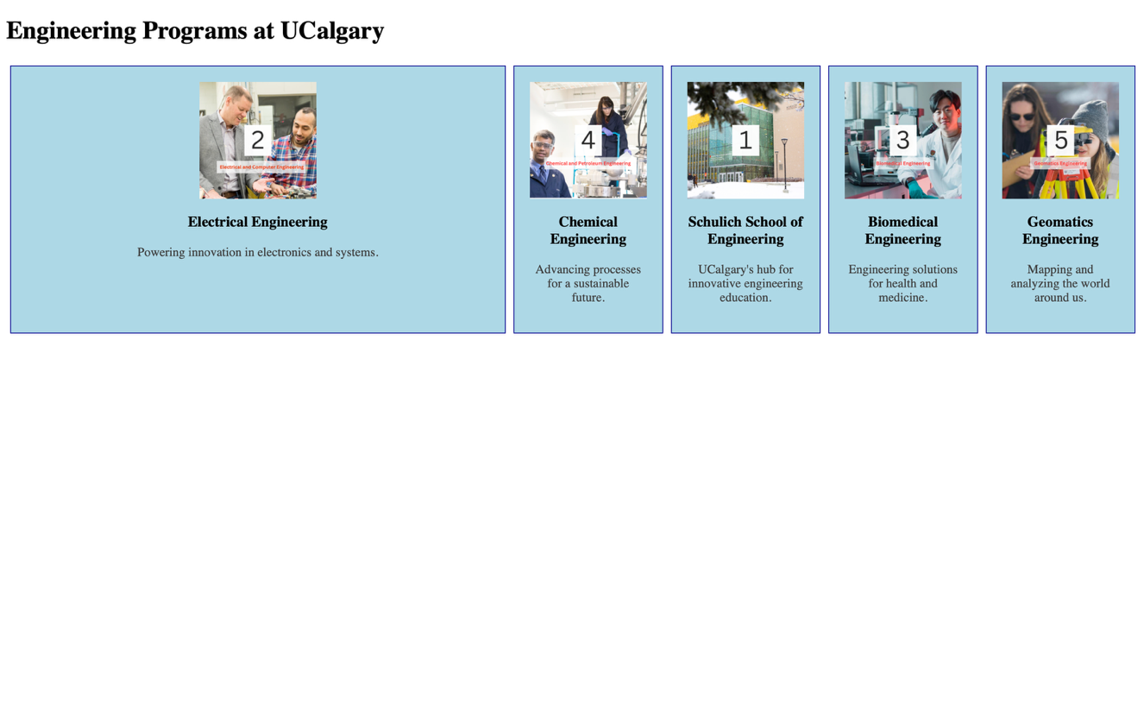

**Exercise 3 Output Screenshot:**

